**What is Evolutionary Computation?**

**Evolutionary Computation** is a branch of artificial intelligence that is inspired by biological evolution to solve complex problems. These algorithms are originated from biological concepts such as selection, mutation, and reproduction. Some of the most common algorithms include **Genetic Algorithms, Evolution Strategies, and Differential Evolution.**

Motivation for Evolutionary Computation

The major motivation for developing evolutionary computation includes −

* Nature has always been an inspiration for engineers and scientists.
* To develop new problem solving methods which is the key theme in mathematics and computer science.
* Increased complexity of problems to be solved.
* Increased requirement for robust problem solving technologies.
* Rise of problems that are too complex to be solved by the existing algorithms.

Implementation of Evolutionary Computation

Following are the steps required to implement evolutionary computation −

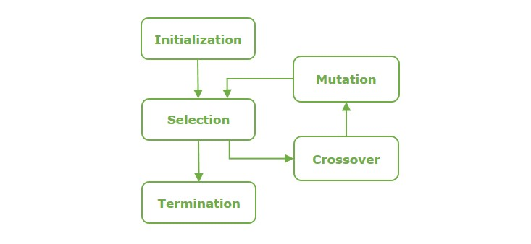

* **Defining Problem:** The initial step involves clearly defining the problems and identifying an optimized solution.
* **Initialization:** A population of potential solution, or individuals is initialized randomly.
* **Selection:** Individuals from the population are selected, based on their fitness to reproduction.
* **Variation:** Selected individuals undergo variations through genetic operators lie crossover and mutation.
* **Evaluation and Iteration:** These newly generated individuals are evaluated, and the cycle is often iterated until a termination is initiated.

Evolutionary Algorithms

**Evolutionary algorithms** are a class of algorithms that use natural section to solve problems. The basic algorithm of evolutionary computation is as follows −

INITIALIZE population w/ random Individuals

REPEAT until

EVALUATE population/individual fitness

SELECT parents with highest fitness

COMBINE parents to form offspring

MUTATE resulting offspring

NEXT POPULATION = offspring

The five key mechanism in evolutionary computation algorithms include **recombination, mutation, evaluation and selection, and mimicking natural processes of evolution in their functioning**.

**Evolutionary Computation encompasses the following AI algorithms −**

* **Genetic Algorithms**
* **Evolution Strategies**
* **Evolutionary Programming**
* **Genetic Programming**

Benefits of Evolutionary Computation

Some of the key benefits of evolutionary computation in businesses and organizations in a number of ways include −

* **Fast Processing Time:** Compared to other manual analysis and more complex AI techniques like neural networks, evolutionary systems have the capability to process large datasets and reach an optimal solution at a faster rate. When the iteration no longer produces better solutions, the process automatically terminates and yields the optimized solution.
* **Enhancing other machine learning methods:** Evolutionary AI algorithms can quickly complete tasks such as classification, and then this information can be fed into more complex machine learning algorithms for further analysis.
* **Network Security:** Evolutionary computation can detect the attacks on networks in real time. This enables companies to act rapidly to malfunctions and major damages.

Applications of Evolutionary Computation

The use cases of evolutionary computation is across various fields and domains −

* **Engineering and Designing:** Evolutionary computation has various applications in numerous engineering fields, from optimizing aerodynamic shapes to designing circuits.
* **Machine Learning:** In [machine learning](https://www.tutorialspoint.com/machine_learning/index.htm), evolutionary computation algorithms can be used to train large datasets especially in neural networks, tune hyper parameters, and evolve decision making.
* **Game Development:** Evolutionary computation algorithms assist in creating intelligent opponents in games, creative and engaging games, and game testing.
* **Bio-informatics:** Evolutionary computation can be used in bio-informatics in domains like gene expression data analysis, prediction of protein structure, and more.
* **Financial Forecasting:** Evolutionary computation can be used in finance sector in tasks like optimizing portfolio, prediction of stock market, and others.

Challenges in Evolutionary Computation

Despite the capabilities evolutionary computation provides, it has certain challenges too which include −

* **Parameter Tuning:** Finding the right parameters for evolutionary algorithms can be a difficult tasks, affecting their efficiency and effectiveness.
* **Convergence Speed:** Evolutionary computation algorithms can sometimes be time-taking to find an optimal solution, which can be a disadvantage while dealings with time-sensitive applications.
* **Noisy and Dynamic Problem Spaces** While evolutionary computation algorithms are effective, they still present complications in maintaining diversity and ensuring convergence.